TokenCap Token (TCT)
Enterprise Architecture and Smart Contract Synchronization Protocol
Aligned to the Definition and Architectural Positioning of TokenCap Token (TCT) memorandum
Document Type | Enterprise architecture and synchronization protocol memorandum
Purpose | Define TCT, show architecture boundaries, and specify TCT <-> TCN outcome synchronization
Primary Use | Input to TCT, TCM, and TCN design specifications
Status | Draft working architecture baseline

Canonical statement
TCT is a non-transferable, identity-bound, cryptographically verifiable token issued by TCM that functions as the control-plane authorization primitive for verified actors, enabling authenticated participation in and interaction with tokenized business collaboration processes executed on TCN, and serving as a verifiable reporting and synchronization layer for smart contract outcomes, without itself conveying or storing economic rights, value, or claims.

1. Executive summary
This document expands the architecture baseline into an enterprise-grade specification that can be used as design input across TCT, TCM, and TCN workstreams. It does two things in one integrated artifact: (i) it defines the production architecture for TCT as a token; and (ii) it specifies the exact smart contract-to-TCT data synchronization protocol required for outcome reporting.
The core architectural rule is simple: TCT authorizes and reports; TCN executes; off-chain legal entities hold value, rights, and risk. This preserves entity separation, reduces regulatory ambiguity, and keeps personally identifiable information off-chain.

2. Design premises and governing constraints
- TCT must remain a token, not merely a generic login credential.
- TCT must be non-transferable, identity-bound, and permissioned.
- TCT must interoperate with the blockchain and execution design selected for TCN.
- TCT may report economic consequences of smart contract results, but must not store value, balances, redemption rights, or ownership claims.
- TCM, TCN, and TCA must remain technologically and operationally separable even where interdependent.
- PII protection and compliance controls are centered in TCM; smart contract complexity is centered in TCN; risk and analytics are centered in TCA.

3. Enterprise architecture model
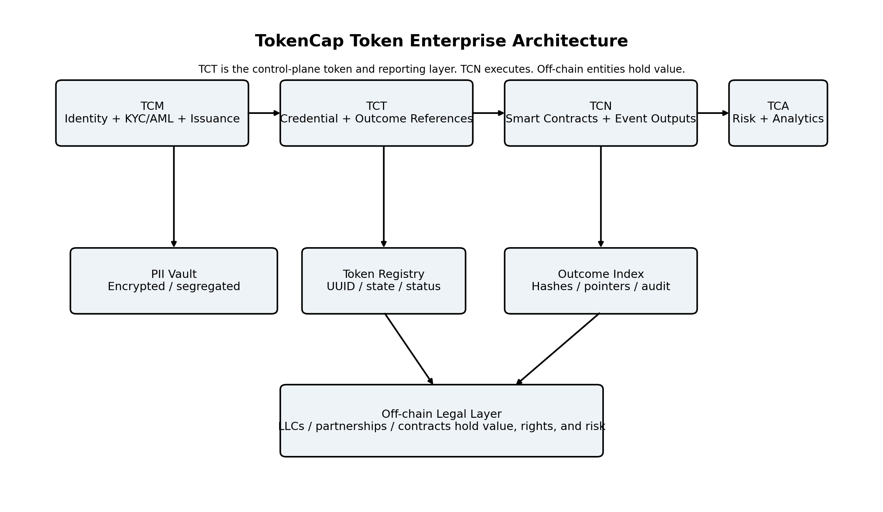
Figure 1. High-level architecture and system boundary model.

3.1 Functional layer definition
Layer | Owned by | Primary responsibility | Must not do
Identity and compliance | TCM | KYC/AML, onboarding, PII controls, UUID binding | Expose PII to chain or TCN
TCT credential and state | TCM with TCN references | Token lifecycle, state, authorization context, outcome references | Store balances, redemption rights, or asset ownership
Execution | TCN | Smart contracts, workflow events, deterministic state transitions | Own identity or compliance master records
Legal / economic | Off-chain entities | Actual rights, assets, proceeds, liabilities, contractual ownership | Assume TCT is itself the asset
Analytics / risk | TCA | Risk scoring, performance analysis, decision intelligence | Control issuance or alter execution state directly

3.2 Definition of TCT as a token
Within the 2678 ecosystem, tokenization refers to the decomposition of business collaboration into machine-readable, executable units such as participant states, workflow steps, approvals, obligations, and recorded outcomes. TCT is the token that anchors a verified actor to that system.
- TCT is not the smart contract itself.
- TCT is not the legal entity itself.
- TCT is not a wallet, stored-value instrument, or economic claim.
- TCT is the actor-linked token that authorizes participation and presents synchronized outcome views.

4. TCT token specification

4.1 Required token properties
- Non-transferable: transfer functions must be disabled or structurally blocked.
- Identity-bound: each token is permanently associated with a verified identity profile or legal participant record.
- Permissioned: issuance and continued use are subject to compliance status and governance controls.
- Cryptographically verifiable: the token must support signed verification and immutable linkage to trusted records.
- Outcome-reporting capable: the token must maintain references to contract results, state changes, and audit-grade timestamps.
- Non-value-bearing: the token must not carry balances, yield, redemption mechanics, or ownership claims.

4.2 Canonical token object
Field | Type | Purpose | Notes
token_id | string / bytes32 | Unique TCT identifier | Globally unique; may be represented on-chain
identity_uuid | UUID | Pseudonymous identity binding key | Maps to PII only inside TCM
issuer | string | Issuing authority | TokenCap Miner LLC
status | enum | Pending / Active / Suspended / Revoked / Expired | Drives authorization outcomes
compliance_status | enum | Verified / Pending / Failed / Restricted | Produced by TCM compliance layer
jurisdiction_code | string | Policy routing and controls | Used for geo/compliance decisions
claims_version | integer | Authorization context version | Supports policy evolution
outcome_refs | array | Pointers to synchronized contract outcomes | No balances; references only
last_sync_at | timestamp | Latest successful synchronization | Audit and freshness control
audit_root_hash | string | Integrity anchor for token record | Protects against tampering

4.3 Outcome reference object
Outcome references are the core mechanism that lets TCT report smart contract consequences without embodying their value.
Field | Purpose | Example | Constraint
event_id | Unique event pointer | 0xabc...:17 | Derived from chain event log
contract_id | Source workflow / contract | DealRoom-Allocation-v3 | Immutable origin reference
event_hash | Payload integrity | SHA-256(...) | Must hash normalized payload
participant_role | Context view for participant | Manager / member / observer | Role is informational, not ownership
result_type | Outcome category | allocation / milestone / vote / distribution notice | No value custody
effective_at | Business effective time | 2026-04-08T15:12:00Z | Supports reporting timeline
ledger_pointer | On-chain reference | block, tx, logIndex | Used to prove origin
offchain_record_ref | Legal / operational linkage | LLC-23-Resolution-5 | Points outward to authoritative record

5. TCM, TCN, and TCA boundary model

5.1 TCM responsibilities
- Issue, revoke, suspend, and renew TCTs.
- Maintain identity binding, PII segregation, and KYC/AML controls.
- Evaluate token state before authorization is granted.
- Ingest, normalize, and synchronize TCN event outcomes into TCT-visible references.
- Maintain immutable audit records for issuance, status changes, and synchronization.

5.2 TCN responsibilities
- Execute tokenized business collaboration processes and smart contracts.
- Emit deterministic, signed, or otherwise verifiable events suitable for synchronization.
- Avoid storing PII or becoming the system of record for identity or compliance.
- Expose finality-aware event interfaces for downstream synchronization services.

5.3 TCA responsibilities
- Consume approved reporting feeds and outcome references for risk and analytics functions.
- Generate performance, exposure, and workflow intelligence products.
- Remain analytically downstream of issuance and execution rather than operationally controlling them.

6. Smart contract to TCT synchronization protocol
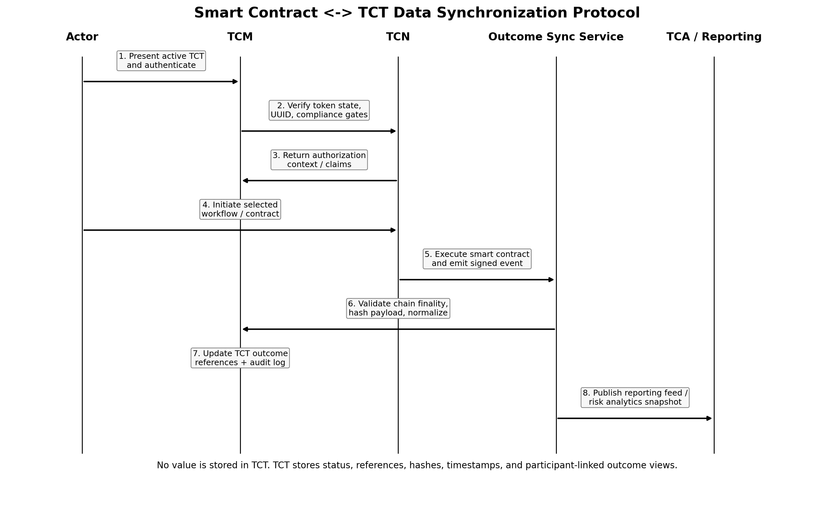
Figure 2. Smart contract-to-TCT synchronization sequence.

6.1 Protocol objectives
- Make smart contract outcomes visible through TCT without converting TCT into a stored-value instrument.
- Preserve deterministic provenance from TCN execution to TCM token state.
- Allow participant-specific reporting views while keeping legal ownership and economic rights off-chain.
- Provide a clean analytics feed for TCA.

6.2 Protocol flow
- Actor presents an active TCT or derived authorization proof to the TCM-controlled authentication gateway.
- TCM validates token status, identity UUID, compliance status, jurisdiction rules, and any workflow-specific policy claims.
- Upon successful validation, TCM issues an authorization context to TCN or to the workflow service layer.
- Actor initiates a selected collaboration workflow or smart contract interaction on TCN.
- TCN executes the contract logic and emits an outcome event containing the minimum synchronization payload.
- The outcome synchronization service waits for defined finality conditions, validates source authenticity, normalizes the payload, hashes the normalized record, and determines participant-specific views.
- TCM updates the token registry and TCT outcome reference set, writing audit logs and refreshing last_sync_at metadata.
- TCA receives an approved reporting feed or snapshot generated from synchronized data for downstream analytics.

6.3 Minimum synchronization payload
Payload field | Source | Required | Description
event_id | TCN | Yes | Unique contract event identifier
chain_reference | TCN | Yes | Block number, tx hash, log index, network id
contract_id | TCN | Yes | Canonical source contract / workflow id
participant_keys | TCN/TCM mapping | Yes | UUIDs or participant pseudonyms affected by event
result_type | TCN | Yes | Allocation, milestone, approval, vote, exception, etc.
result_payload | TCN | Yes | Normalized business output for reporting
effective_timestamp | TCN | Yes | Event business time
offchain_authority_ref | Workflow / legal layer | Recommended | Reference to authoritative legal or operational record
finality_proof | Chain / node layer | Recommended | Confirmation that event is safe to synchronize

6.4 Synchronization rules
- No raw PII may enter the synchronization payload.
- All participant identifiers must be UUIDs, pseudonyms, or equivalent indirect references.
- Synchronization must be finality-aware; provisional chain events must be flagged as pending or excluded until threshold is met.
- The payload must be normalized before hashing so the same event always yields the same integrity value.
- Outcome references stored against TCT must point to results, not balances.
- If an off-chain legal record supersedes an on-chain event for legal interpretation, the TCT reference must show the linkage without rewriting chain history.

6.5 Failure handling
Failure condition | Required handling | Resulting token state impact
Chain reorg before finality | Delay synchronization or mark provisional | No permanent outcome reference written
Signature / source validation failure | Reject payload and alert operations | No update; audit exception logged
Participant mapping failure | Queue for manual resolution or policy fallback | Outcome held outside participant view until resolved
Compliance status changed before sync completes | Re-run policy evaluation before publishing view | Outcome may sync but access visibility may be restricted
Duplicate event delivery | Apply idempotency check on event_id + hash | Single canonical reference only

7. Security architecture
- PII isolation: identity records remain in a segregated TCM vault and are never written to chain.
- Pseudonymization boundary: all downstream systems consume indirect participant references.
- Immutable audit logging: issuance, authorization, synchronization, and revocation events are written to tamper-evident logs.
- Key management: signing keys, token verification keys, and vault encryption keys must be separated by function and rotated under policy.
- Least-privilege service design: outcome synchronization services may read chain events and token registry records, but may not read full PII unless explicitly required and controlled.
- Zero-trust access: every internal service call is authenticated, authorized, and logged.

8. Compliance and classification guardrails
The architecture must preserve a hard distinction between reporting on value and representing value. That distinction is not rhetorical; it is implemented technically.
Permitted in TCT | Prohibited in TCT | Authoritative location
Outcome references, result categories, timestamps, hashes, role-context views | Balances, redeemable units, wallet logic, ownership interests, claims on assets | Off-chain legal entities and governing contracts
Synchronization pointers to contract results | Stored value or redemption mechanics | TCN execution records plus legal agreements
Authorization status and compliance metadata | Economic custody or intermediation | TCM compliance layer and off-chain finance ops

9. API and service interface baseline

9.1 Core services
- Token Issuance API - creates token_id, binds UUID, sets initial status.
- Authentication / Claims API - validates TCT and returns authorization context.
- Outcome Sync Ingestion API - accepts normalized chain-event payloads from the synchronization service.
- Token Reporting API - returns participant-specific synchronized views.
- Revocation / Suspension API - updates lifecycle state and policy enforcement.
- Analytics Feed API - publishes approved, pseudonymized reporting data to TCA.

9.2 Idempotency and integrity requirements
- All synchronization writes must be idempotent on event_id plus normalized event_hash.
- Every TCT update must generate a new audit_root_hash or equivalent immutable integrity marker.
- Time ordering must be explicit: event occurrence time, chain confirmation time, sync ingest time, and publish time should be preserved separately.

10. Implementation directives
- Treat TCT as a token, credential, authorization primitive, and outcome-reporting layer in every downstream specification.
- Keep the TCM identity plane and TCN execution plane separated by UUID-based interfaces and policy-checked APIs.
- Design TCN event schemas early; TCT synchronization quality depends on stable, deterministic event output definitions.
- Define off-chain legal record identifiers in parallel with contract design so synchronized outcome references can point to authoritative records where needed.
- Do not let reporting features drift into balance presentation, redemption logic, or claim representation.
- Use this document as a baseline for the detailed TCT protocol specification, TCM cloud design, and TCN smart contract event schema.

11. Conclusion
This architecture treats TCT as a true token within the 2678 system, while preserving the distinctions necessary for security, separability, and regulatory clarity. TCT is the identity-bound control-plane token and participant reporting surface. TCN is the execution substrate. Off-chain entities remain the holders of value, rights, and risk. That model supports the broader vision of tokenized business collaboration without collapsing the architecture into a stored-value or entitlement instrument design.

